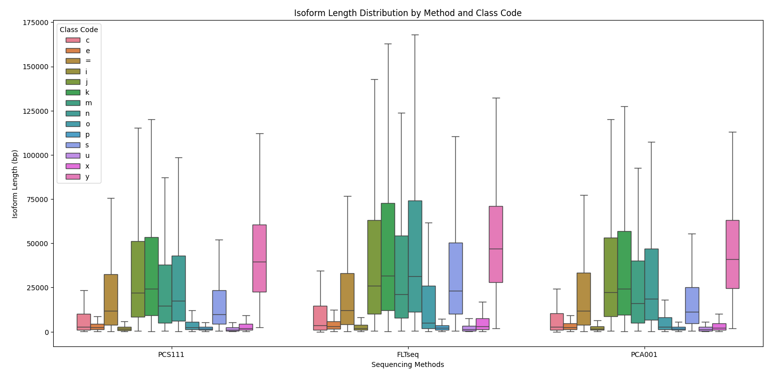
Figure S3 - Isoform length distribution comparison between PCS111, FLT-seq, PCA001 and scmixology2 and across different class codes.

Figure Description -

Code | Description
= | Complete, exact match of intron chain
c | Contained in reference (intron compatible)
k | Containment of reference (reverse containment)
m | Retained intron(s), all introns matched or retained
n | Retained intron(s), not all introns matched/covered
j | Multi-exon with at least one junction match
e | Single exon transfrag partially covering an intron, possible pre-mRNA fragment
o | Other same strand overlap with reference exons
s | Intron match on the opposite strand (likely a mapping error)
x | Exonic overlap on the opposite strand (like o or e, but on the opposite strand)
i | Fully contained within a reference intron
y | Contains a reference within its intron(s)
p | Possible polymerase run-on (no actual overlap)
r | Repeat (at least 50% bases soft-masked)
u | None of the above (unknown, intergenic)

